**Chapter 13 Maintenance**

In this Chapter:

*13.1 Maintenance*

*13.1.1 Company Info*

*13.1.2 System Preferences (Not completed)*

*13.1.3 Data Lookup*

*13.1.4 Holiday*

*13.1.5 Location*

*13.1.6 Task Template*

*13.1.7 Fund Category*

*13.1.8 Activity*

*13.1.9 Bill Template*

*13.1.10 Message/Notes Template*

*13.1.11 Calculator*

*13.1.12 Doc. No./File No. Format*

*13.1.13 Agent*

*13.2 Users and Groups*

*13.2.1 User Account*

*13.2.2 User Groups & Roles*

*13.2.3 Access Control*

*13.3 User Settings*

*13.3.1 Change Password*

*13.3.2 My Profile*

*13.3.3 Theme Color*

*13.4 Accounting*

*13.4.1 G/L Settings*

*13.4.2 Fiscal Year*

*13.4.3 GL Account Code*

*13.4.4 Account Balance*

*13.5 Tax*

*13.5.1 Tax Settings*

*13.5.2 Tax Code Maintenance*

*13.6 File Type & Templates*

*13.6.1 File Type Designer*

*13.6.2 Template Explorer*

*13.7 Reporting*

*13.7.1 Manage Reports*

*13.7.2 Report Options*

*13.8 System*

*13.8.1 System Event*

*13.8.2 Restart*

**13.1 Maintenance**

**13.1.1 Company Info**

This option enables you to edit your company information in the system.

* To open ‘**Company Info**’ window, go to maintenance Menu and click ‘**Company Info**’.
* A ‘**Company Info**’ window will appear as below.

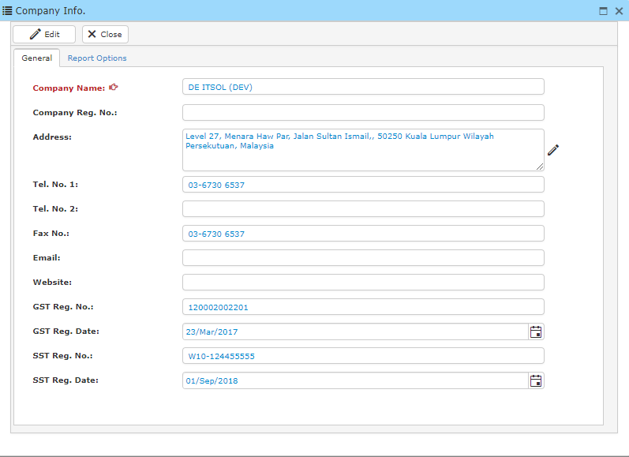

* Click **Edit** and enter your company’s name, address, telephone number etc.
* You can also modify the printed report by clicking **‘Report option’**. You may upload information and logo for reporting printing purposes.

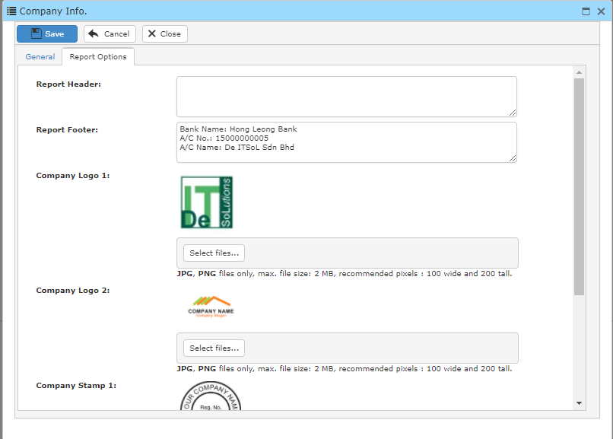

* Once you have completed, click **Save.**

**13.1.2 System Preferences**

This option enables you to edit your system preferences.

* To open ‘**System Preferences**’ window, go to maintenance Menu and click ‘**System Preferences**’.
* A ‘**System Preferences**’ window will appear as below.

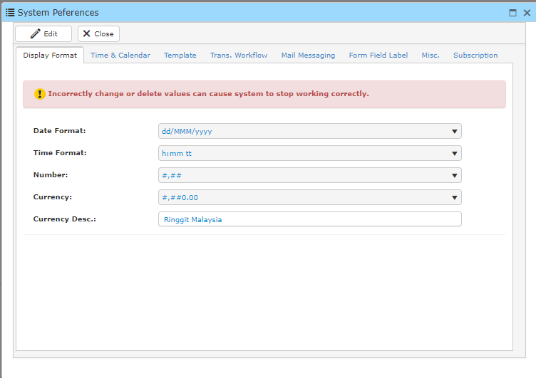

* In ‘**Display Format**’ , you may change the date format, time format,ways to present numbers (EG: 1,234 / 1234), Currency (EG: RM 1,234.00 / RM1234.00) and Currency Description.
* In ‘**Time & Calendar**’ you may change the settings according to your preference.  
  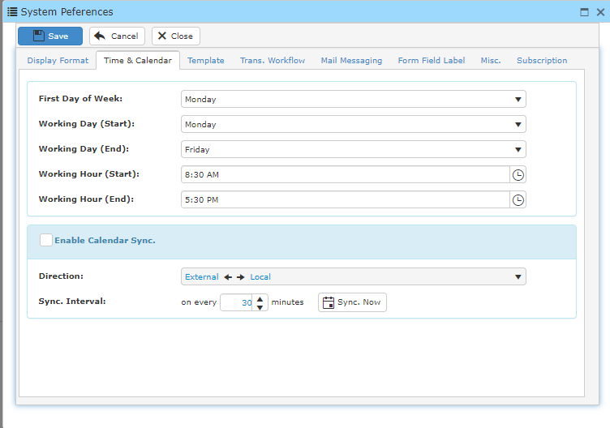
* In ‘**Trans. Workflow**’ you may change the workflow level of the trans. type.

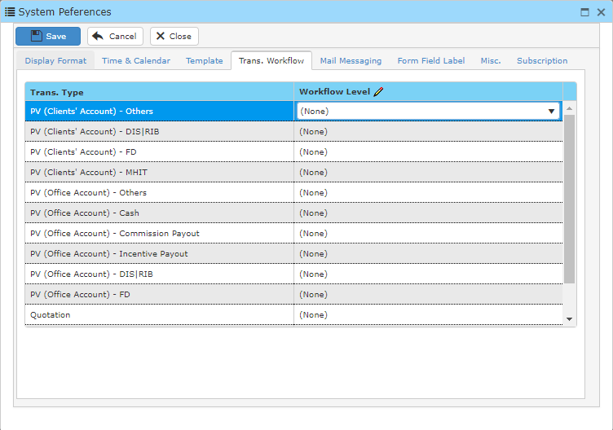

**13.1.3 Data Lookup**

This option enables you to edit the system’s data.

* To open ‘**Data Lookup**’ window, go to maintenance Menu and click ‘**Data Lookup**’.
* A ‘**Data Lookup**’ window will appear as below.

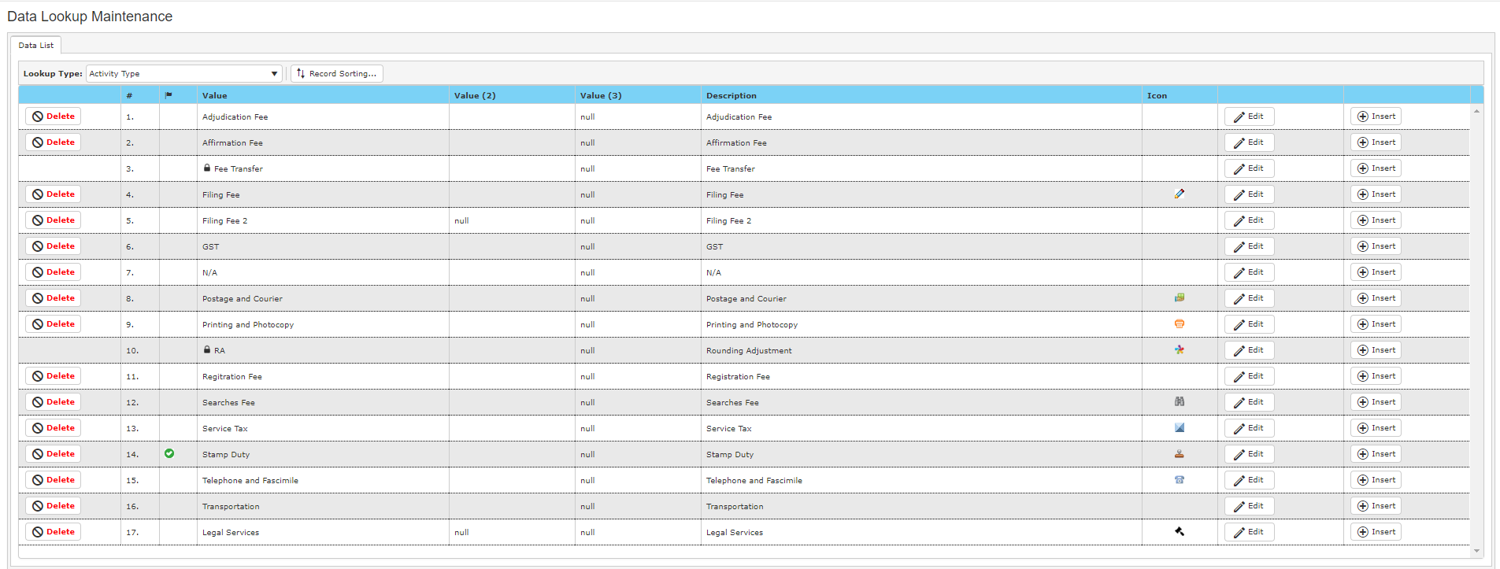

* At the Lookup Type, you may select any data type you want to view.

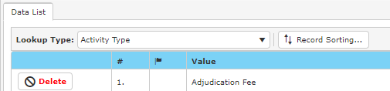

* After locating the data you are looking for, you may click **Delete** to delete the data, **Edit** to edit the data (EG: Changing description) and Insert new data.
* Click **Update** once you has finished editing the data.



* To sort data, click **Record Sorting** to change the arrangement of data.

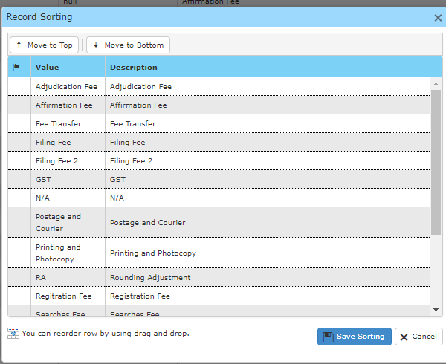

* You may reorder the row by using drag and drop.
* Click **Save Sorting** once you have completed sorting.

**13.1.4 Holiday**

This option enables you to edit the existing holidays in the system.

* To open ‘**Holiday**’ window, go to maintenance Menu and click ‘**Holiday**’
* .A ‘**Holiday**’ window will appear as below.

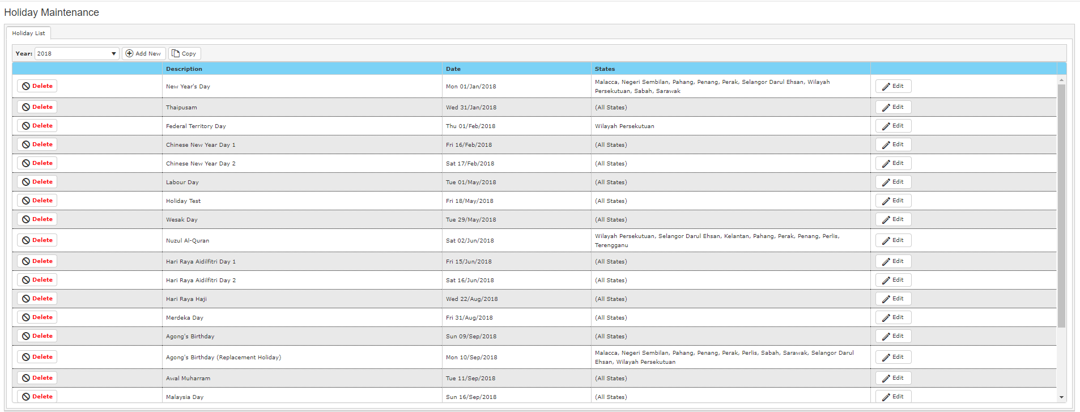

* You may add new holiday by clicking **Add New** and fill in the relevant information.
* Click **Update** once you have finished.
* You may also delete holiday by clicking **Delete**.
* Click **Edit** to edit the description of holiday and the date of the holiday. You may also edit the states that will be having the holiday as well.

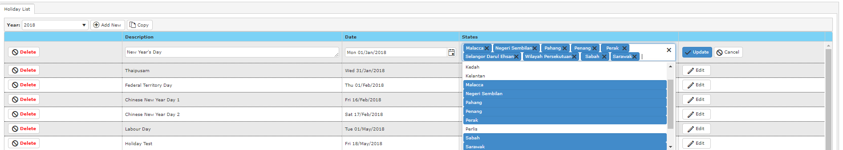

**13.1.5 Location**

This option enables you to search and edit the existing location in the system.

* To open ‘**Location**’ window, go to maintenance Menu and click ‘**Location**’.
* A ‘**Location**’ window will appear as below

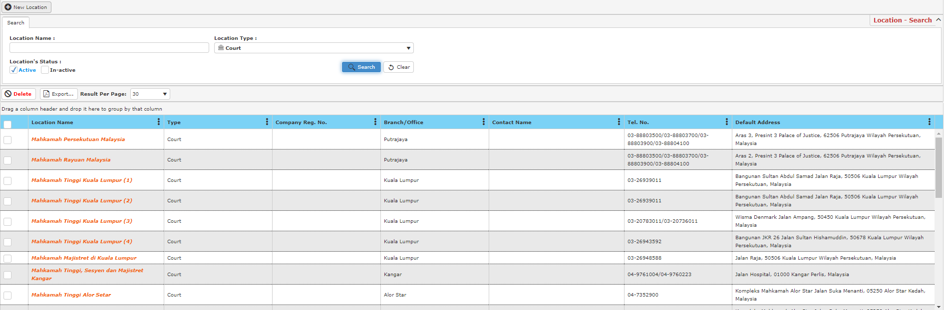

* To add a new location, click **New Location** and new window will appear as below.

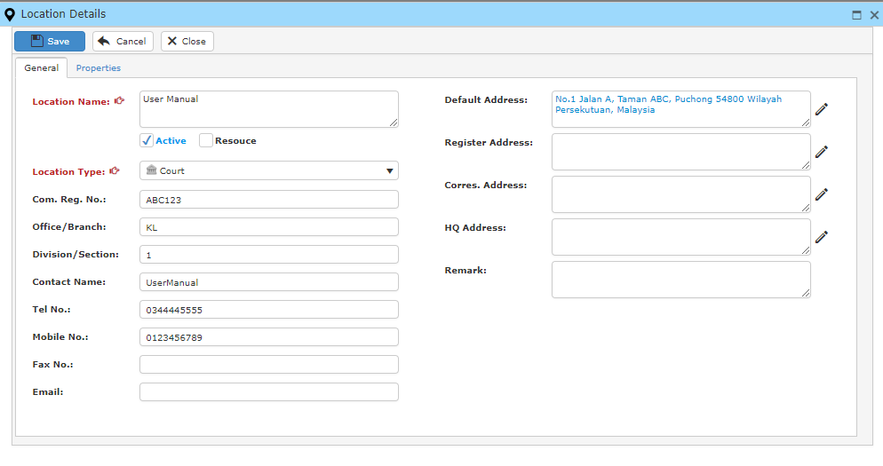

* Enter relevant information and click save to proceed.

**Search Location**

* To search for a location, type in location name and choose the type of location and click **Search**. You may also tick the checkbox for the location’s status.

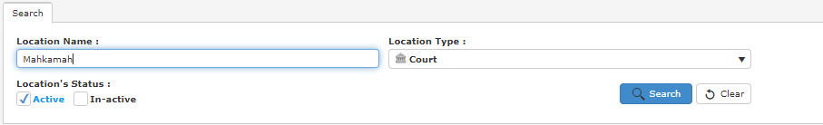

* A result list will be displayed as below.

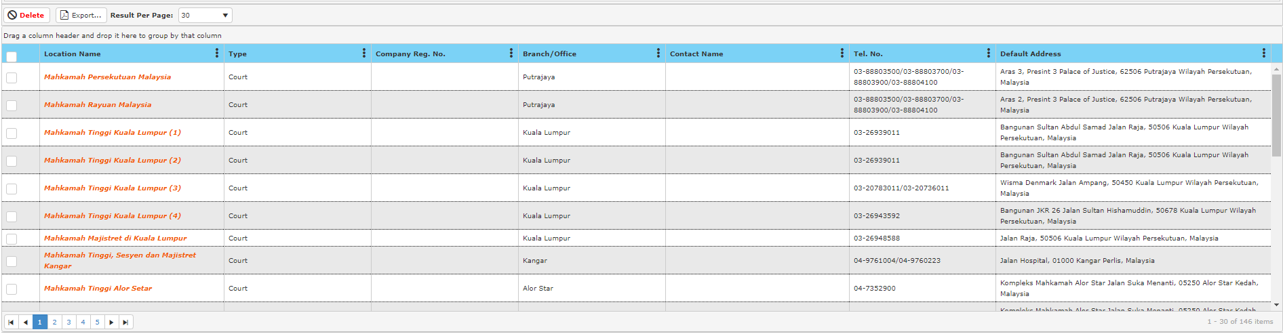

* You may double click to view the details of the location.
* Press **Edit** to edit the information of the location.
* After you have completed, press **Save.**

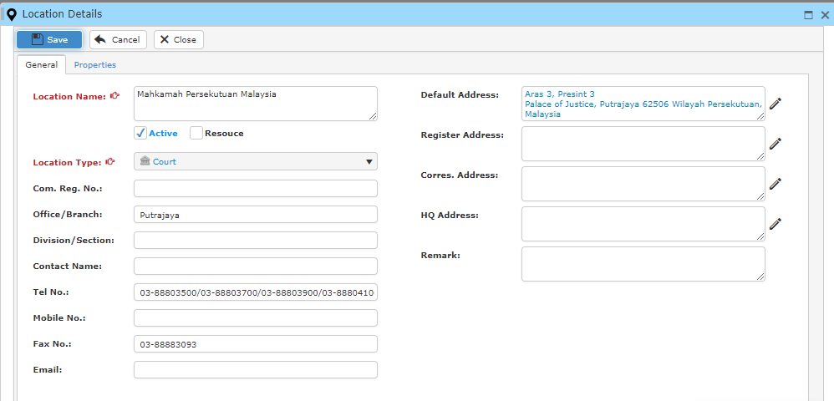

**13.1.6 Task Template**

This option enables you to edit or create task template in the system.

* To open ‘**Task Template**’ window, go to maintenance Menu and click ‘**Task Template**’.
* A ‘**Task Template**’ window will show as below.

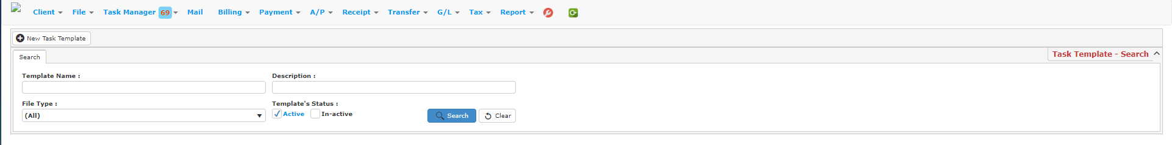

**Search Task**

* To search a task. You may type in your search criteria and click the **Search** button and a result will be displayed.

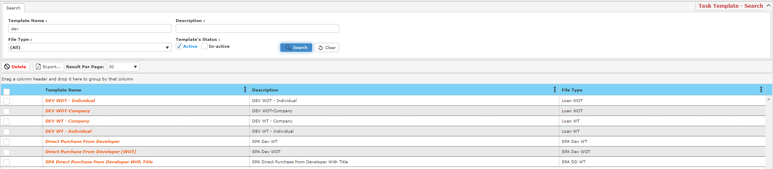

**Creating New Task Template**

* To create a new task template, click **New Task Template**.
* A window will show as below.

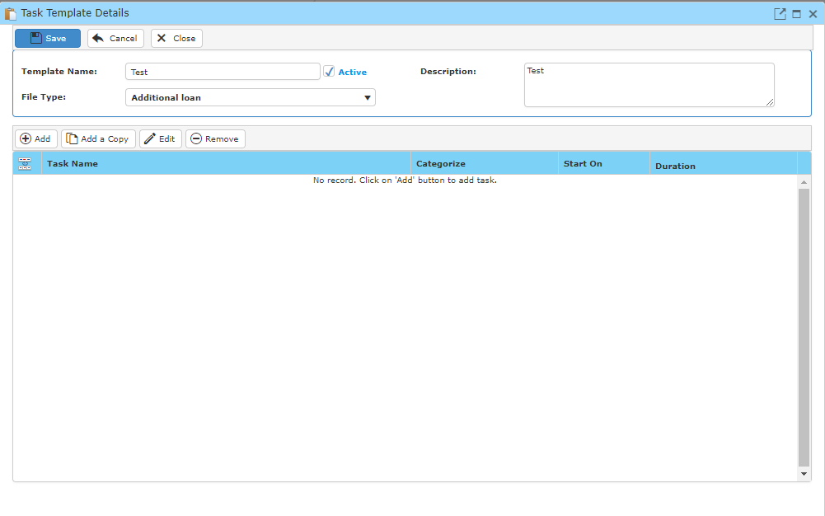

* Click **add** to add in task to the task template.
* A window will show as below.

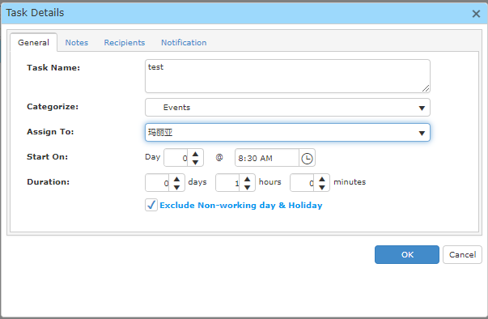

* Fill in the form below and click ok.
* When you are done, click **Save** and the task template will be saved.

**13.1.7 Fund Category**

This option enables you to edit or create fund category in the system.

* To open ‘**Fund Category**’ window, go to maintenance Menu and click ‘**Fund Category**’.
* A ‘**Fund Category**’ window will show as below.



**Search Fund Category**

* To search a fund category, fill in the search criteria and click **Search.**

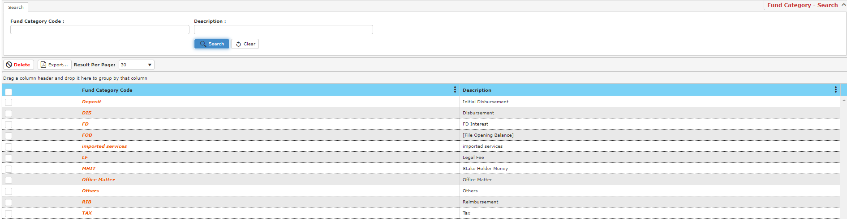

**Creating New Fund Category**

* To create a new fund category, click **New Fund Category** and a window will pop up as below.

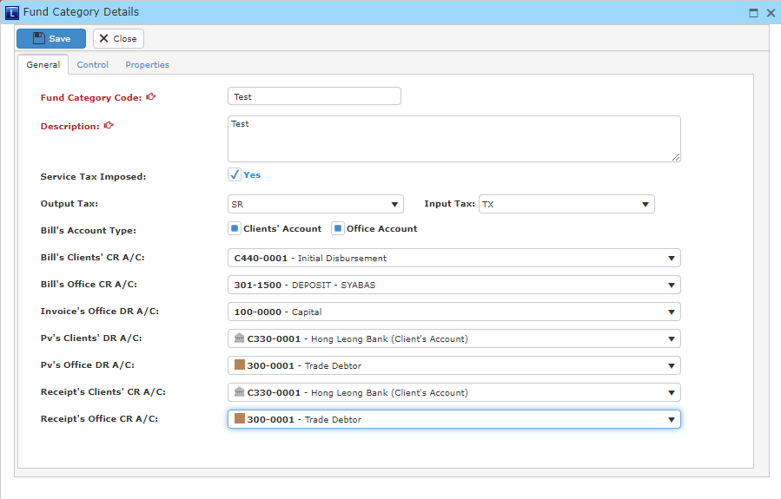

* Fill in all the field below and click **Save** once you have done.

**13.1.8 Activity**

This option enables you to edit or create activity codes in the system.

* To open ‘**Activity**’ window, go to maintenance Menu and click ‘**Activity**’.
* A window will show as below.

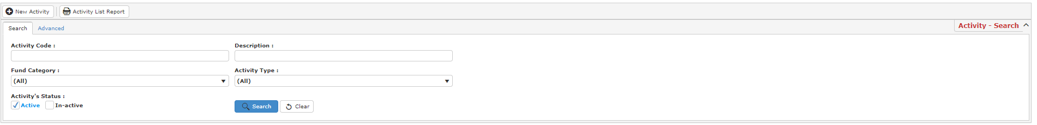

**Search Activity**

* To search an activity, type in your search criteria and click **Search** and a result list will be displayed.

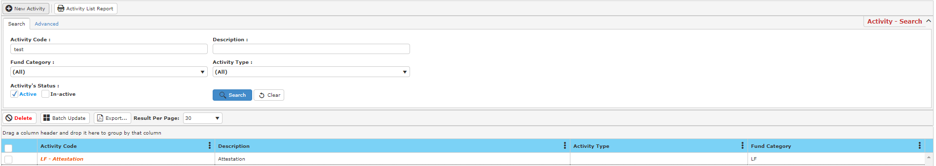

**Creating New Activity**

* To create a new activity, click **New activity** and a window will show as below.

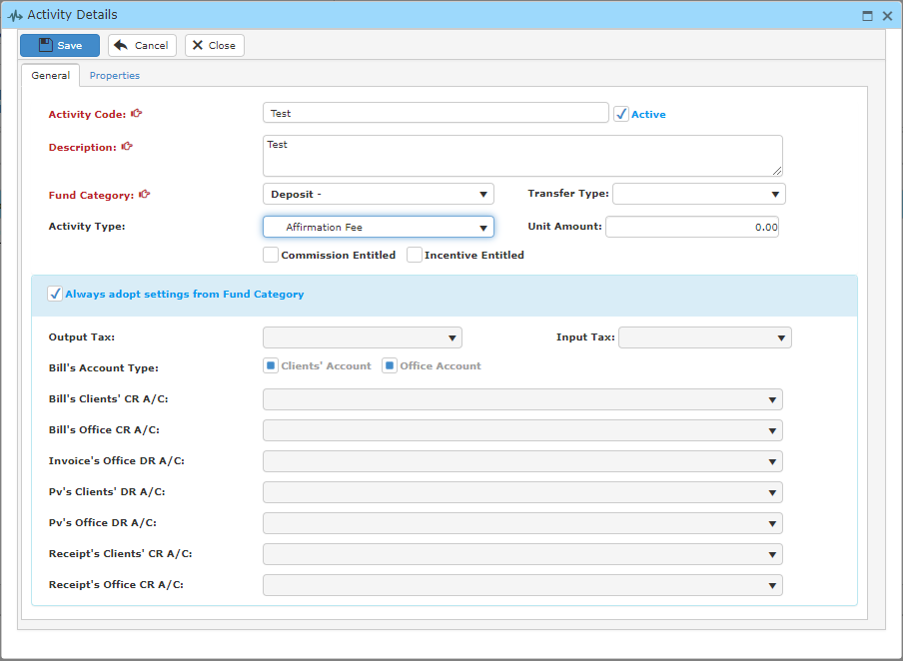

* Fill in the fields below and click save. Always tick the checkbox for **always adopt settings from Fund Category** to allow the system to automatically find the correct accounts.

**13.1.9 Bill Template**

This option enables you to edit or create bill template in the system.

* To open ‘**Bill template**’ window, go to maintenance Menu and click ‘**Bill template**’.
* A window will show as below.

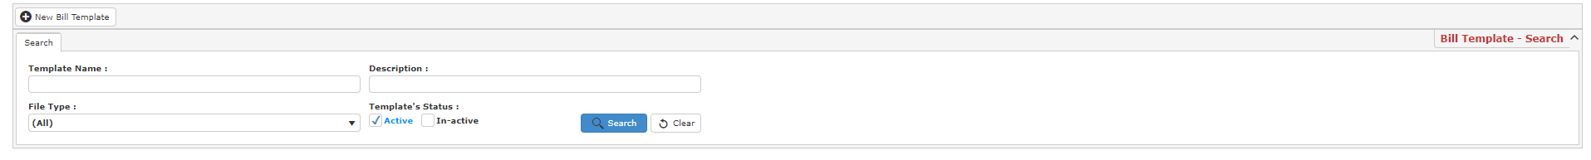

**Search bill template**

* To search a bill template, type in your search criteria and click **Search** and a result list will display as below.

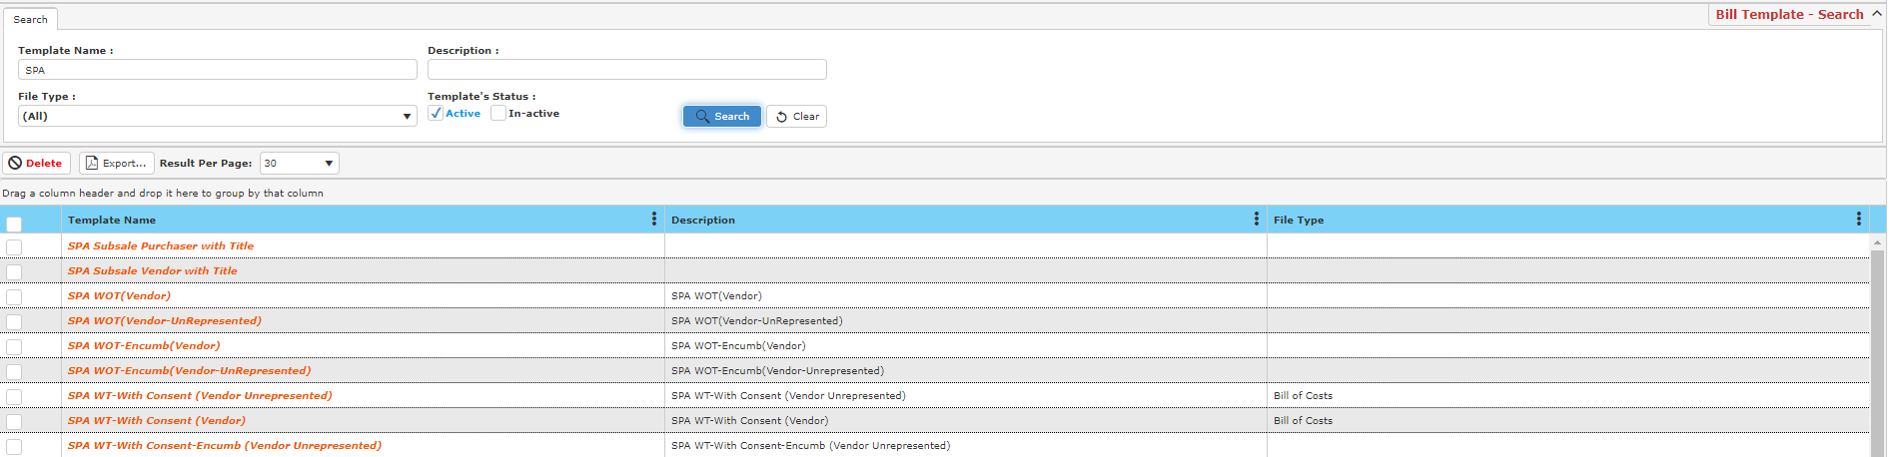

**Creating Bill Template**

* To create a new bill template, click **New Bill Template** and a window will show as below

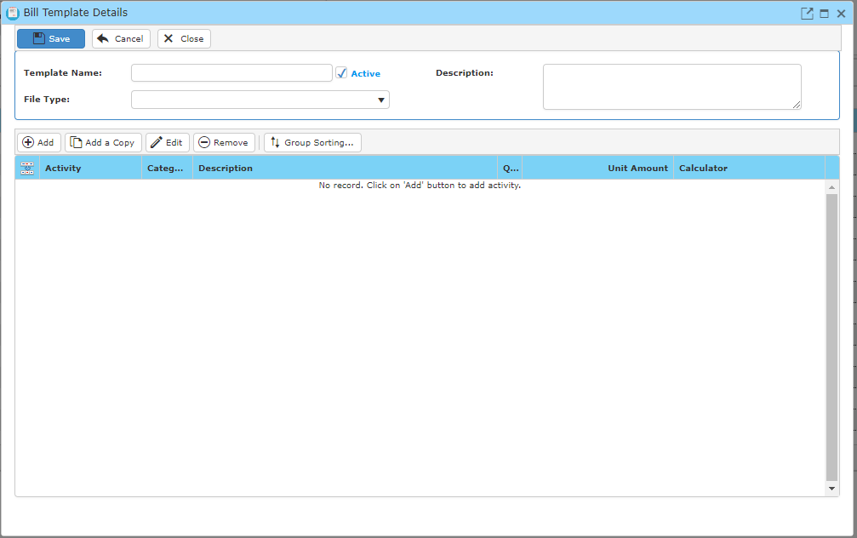

* To add activities into the bill, click **add** and a window will appear as below.

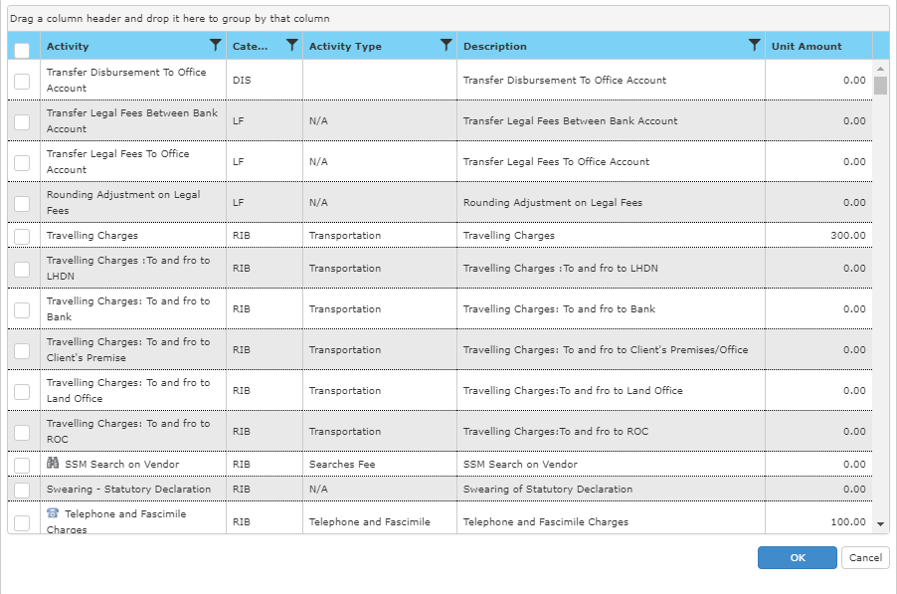

* Tick any checkbox of the activity you would like to choose.
* To quickly locate activity you are looking for, click  at activity and change your search option to ‘Contains’ to find any activity that has this word.

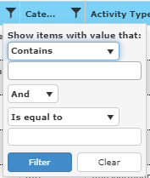

* Click filter and the activity list will be filtered.

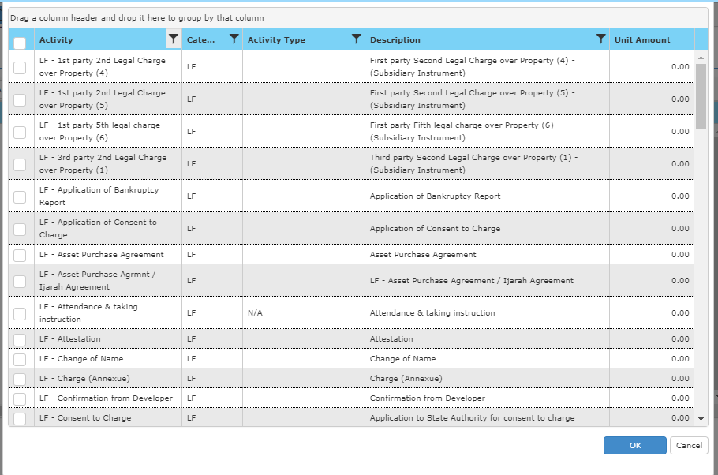

* Once you have done, click **Save** to proceed.

**13.1.10 Message/Notes Template**

This option enables you to edit or create message/notes template in the system.

* To open ‘**Message/Notes Template**’ window, go to maintenance Menu and click ‘**Message/Notes Template**.
* A window will show as below.



**Search Note**

* To search a note, fill in your search criteria and click **Search** and a result list will be displayed.

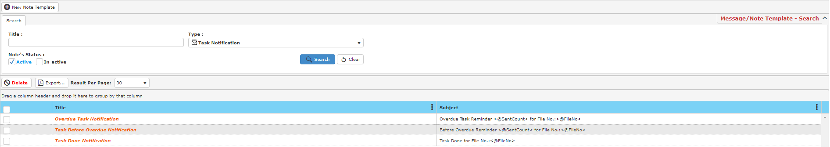

**Creating New Note Template**

* To create a new note template, click **New Note Template** and a window will display as below.

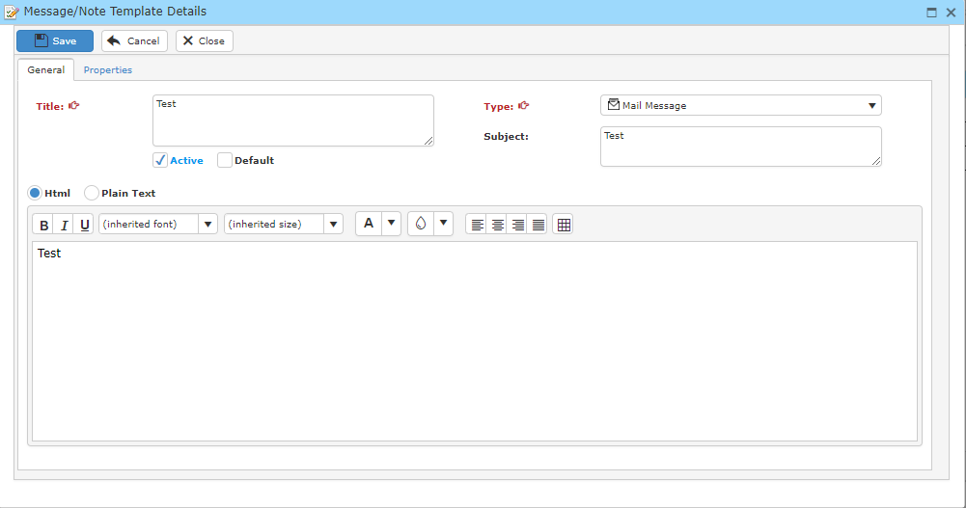

* Fill in the fields below and click **Save** once you have completed.

**13.1.11 Calculator**

This option enables you to edit or create calculator in the system.

* To open ‘**Calculator**’ window, go to maintenance Menu and click ‘**Calculator**’.
* A window will show as below.



**Search Calculator**

* To search for a calculator, fill in the search criteria and click **Search** and a result list will display below.

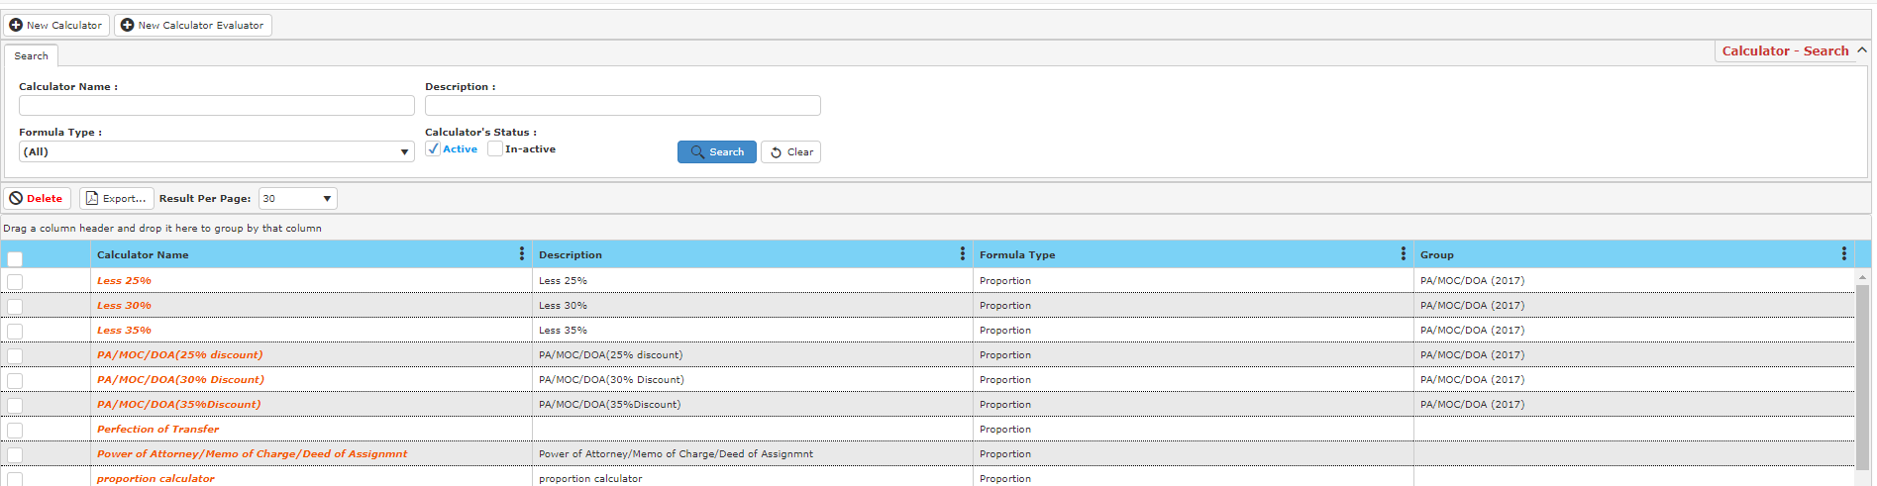

**Creating New Calculator**

* To create a new calculator, click **New Calculator** and a window will display as below.

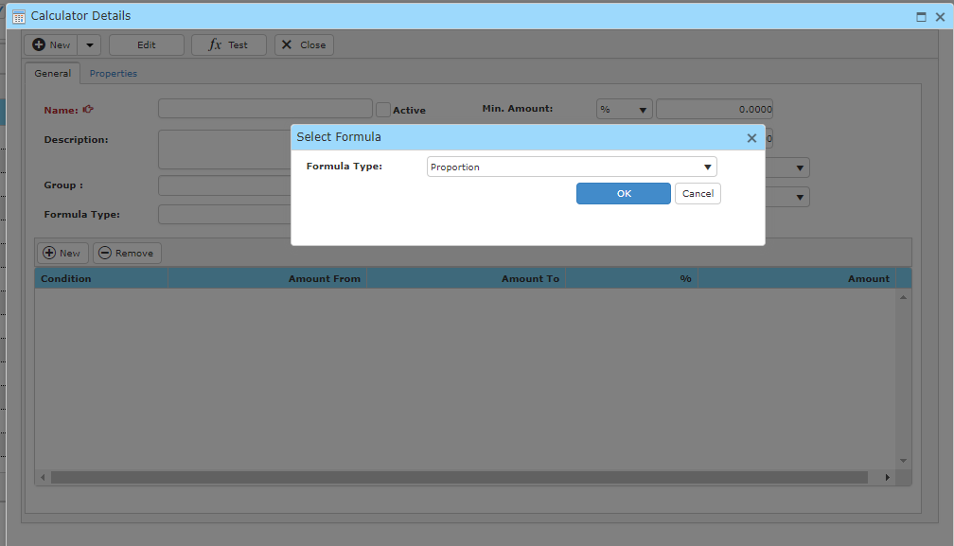

* To begin, choose a formula type and click **OK**.
* Then, fill in all the fields.

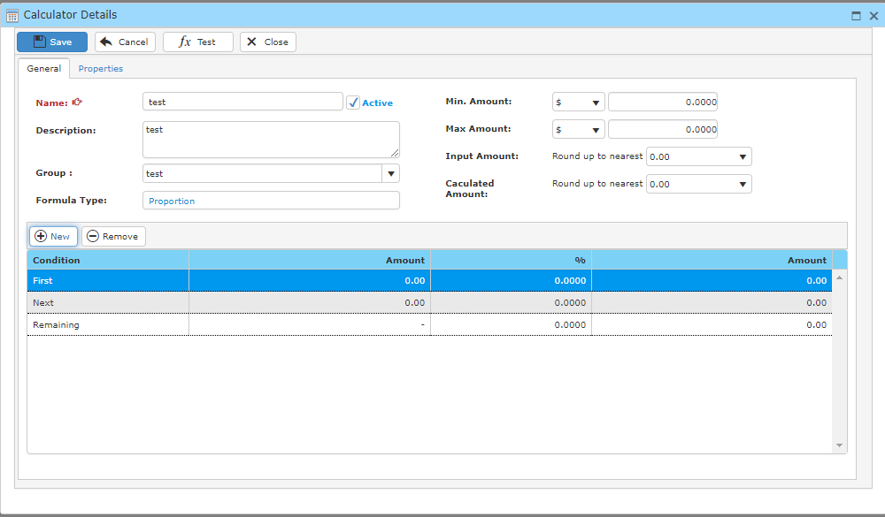

* To add a condition, click **New** and a condition will be added to the calculator. You may also edit the value of the condition by double clicking the value you wish to edit.
* Once you have completed, click **Save.**

**Evaluating a Calculator**

* To evaluate a calculator, click **New Calculator Evaluator**.

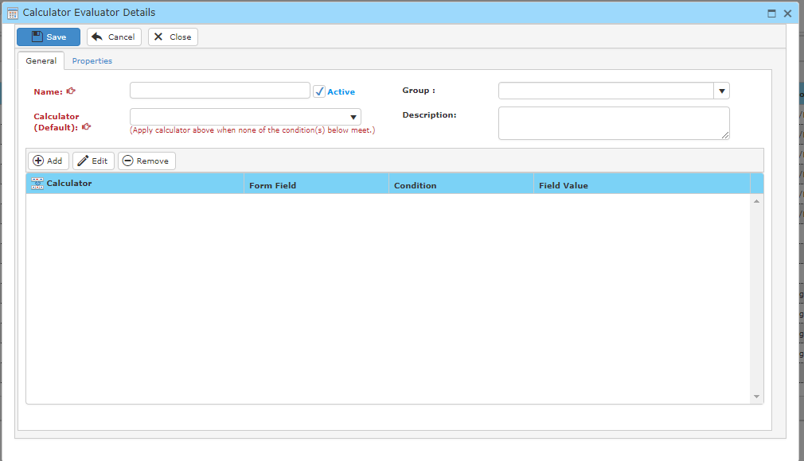

* Fill in the field below.
* Click **Add** to add in any calculator that meets the condition you filled into the field previously.
* Once you have completed, click **Save**.

**13.1.12 Doc. No./File No. Format**

This option enables you to edit the doc. no./file no. format in the system.

* To open ‘**Doc. No./File No. Format**’ window, go to maintenance Menu and click ‘**Doc. No./File No. Format**’.
* A window will show as below.

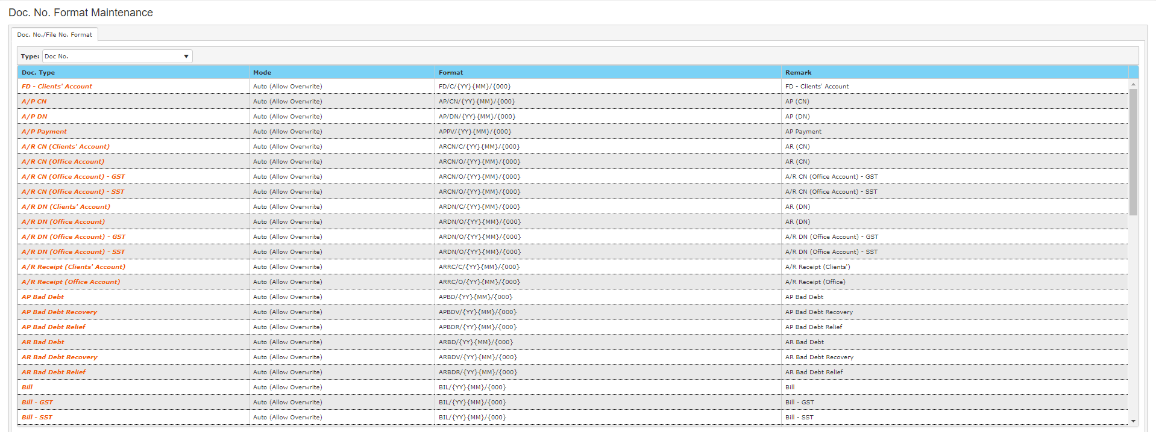

* To edit a format for a doc. type, double click the doc. type to view its detail.

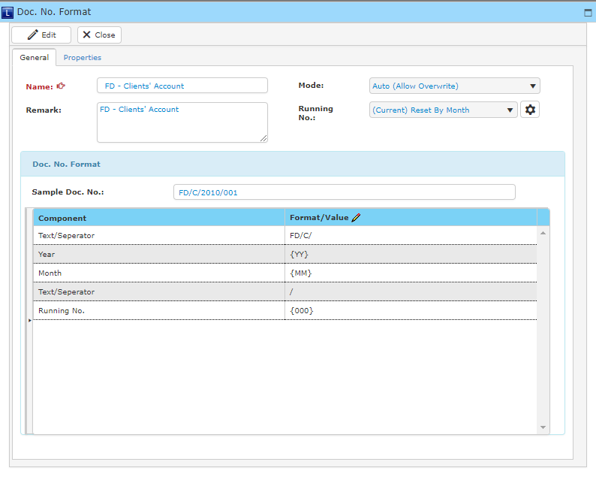

* Click edit and change any information you wish to change.
* Once you have done, click **Save** to proceed.

**13.1.13 Agent**

This option enables you to edit or create agents in the system.

* To open ‘**Agent**’ window, go to maintenance Menu and click ‘**Agent**’.
* A window will show as below.



**Search Agent**

* To search for an agent, fill in the search criteria and click **Search** and a result list will be displayed.

**Creating New Agent**

* To create a new agent, click **New Agent** and a window will display as below.

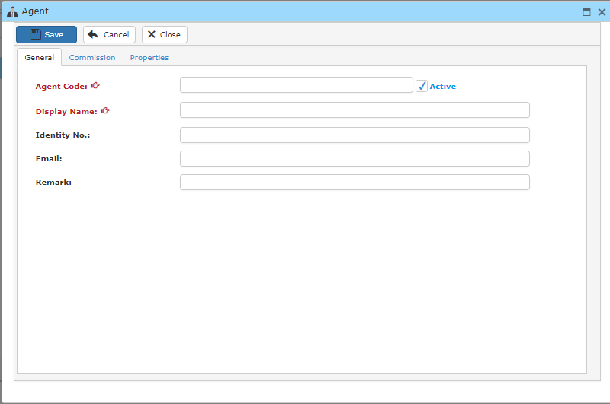

* Fill in any necessary information and click save once you have done.
* To add commission to an agent, go to **Commission** and click **Add Commission.**

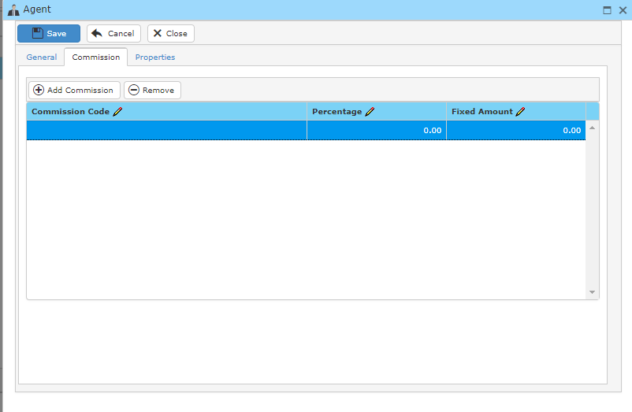

**13.2 Users and Groups**

**13.2.1 User Account**

This option enables you to edit or create user account in the system.

* To open ‘**User Account**’ window, go to maintenance Menu and click ‘**User Account**’.
* A window will show as below.



**Search User Account**

* To search for an user account, fill in search criteria and click **Search** and a result list will be displayed.

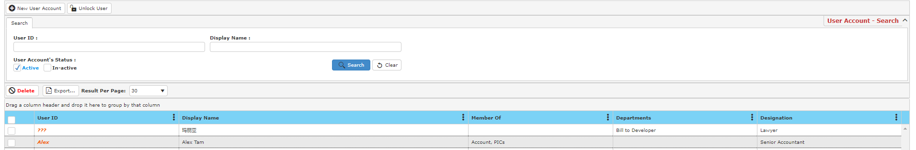

**Creating New User Account**

* To create a new user account, click **New User Account** and a window will be displayed as below.

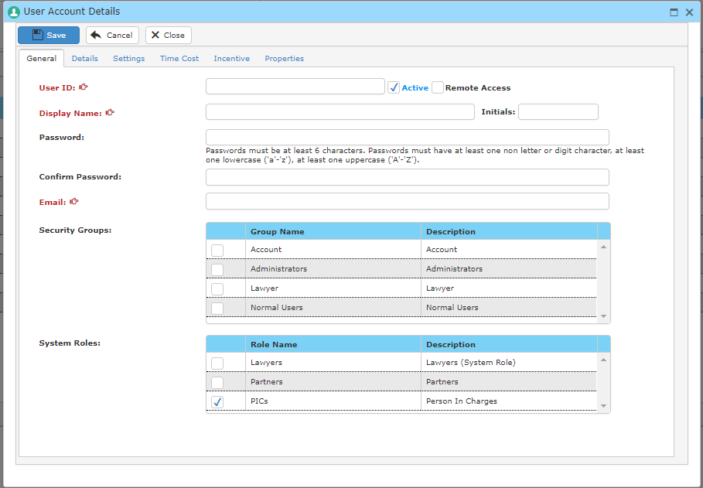

* Fill in all the fields below. You may also add more information related to this user account in the following tabs:



Details

Settings

Time cost

Incentive

* Click **Save** once you have done.

**Unlock User**

* To unlock an user, click **Unlock User** and a window will be displayed as below.

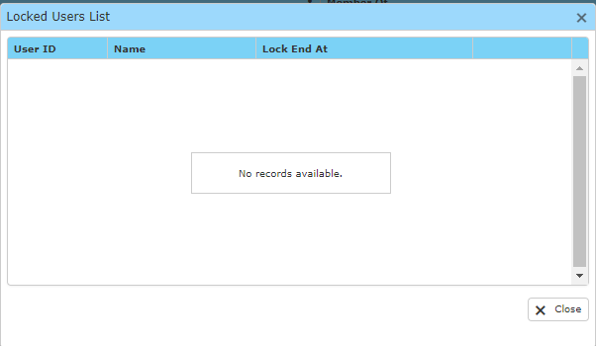

**13.2.2 User Groups & Roles**

This option enables you to edit or create user groups in the system.

* To open ‘**User Groups & Roles**’ window, go to maintenance Menu and click ‘**User Groups & Roles**’.
* A window will show as below.



**Search User Group**

* Fill in your search criteria and click **Search** and a result list will be displayed as below.

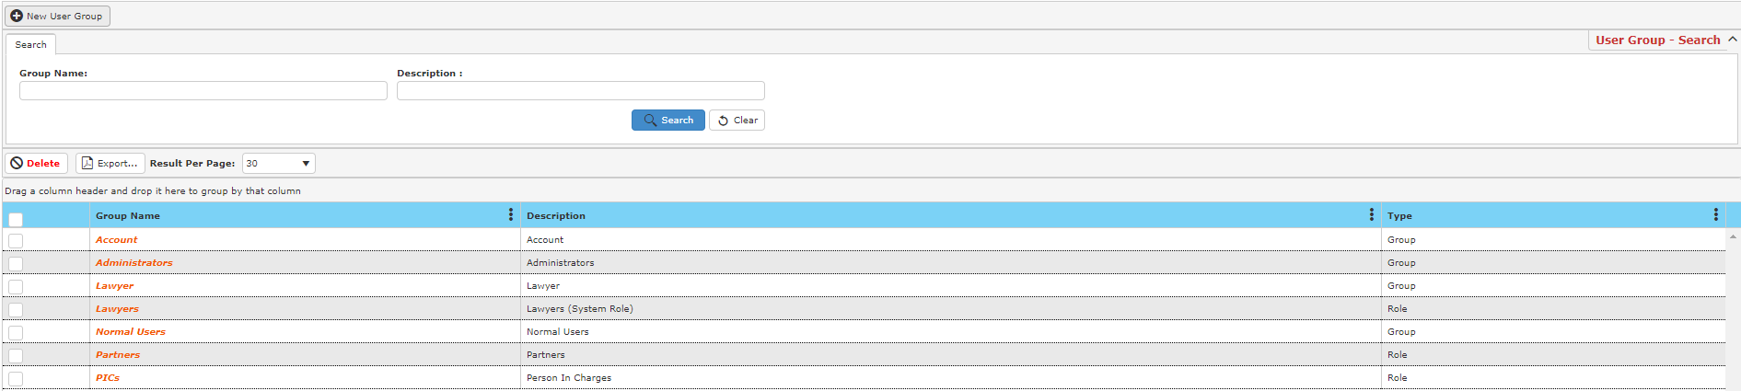

**Creating New User Group**

* To create a new user group, click **New User Group** and a window will be displayed as below

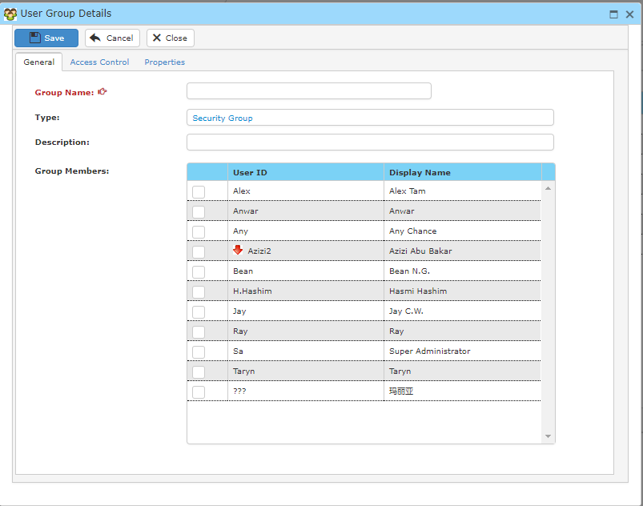

* Fill in the fields below and tick any User ID that you want to add into this group.
* In **Access Control**, you may give any related access rights to the following user by ticking the checkbox.

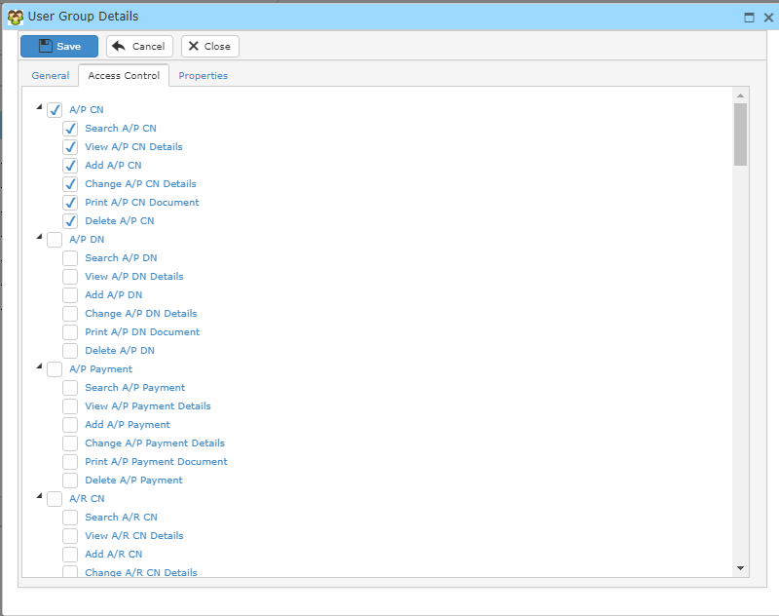

* Click **Save** once you have completed.

**13.2.3 Access Control**

This option enables you to edit the accounts’ access rights in the system.

* To open ‘**Access Control**’ window, go to maintenance Menu and click ‘**Access Control**’.
* A window will show as below.

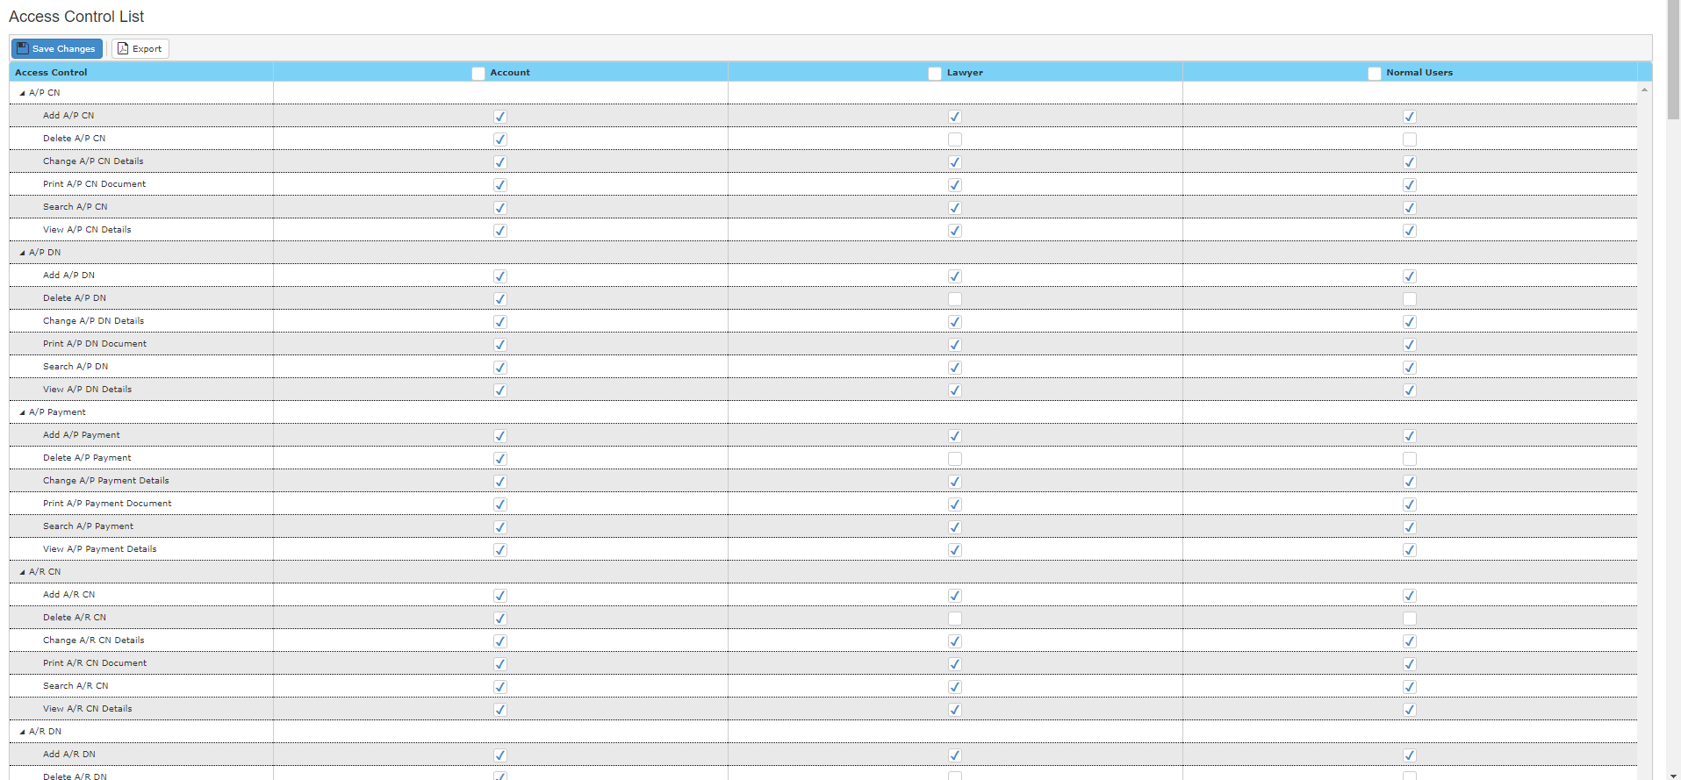

* You may tick/untick the checkboxes to give access rights to user or restrain them from accessing the related subject.
* Click **Save Changes** once you have completed.

**13.3 User Settings**

**13.3.1 Change Password**

This option enables you to change password in the system.

* To open ‘**Change Password**’ window, go to maintenance Menu and click ‘**Change Password**’.
* A window will show as below.

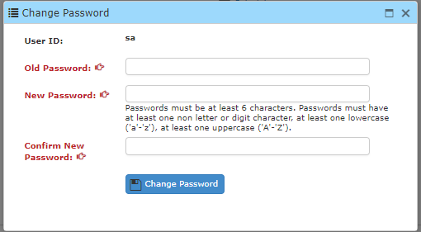

* Type in your **Old Password and New Password** and click **Change Password** to proceed.

**13.3.2 My Profile**

This option enables you to edit your profile in the system.

* To open ‘**My Profile**’ window, go to maintenance Menu and click ‘**My Profile**’.
* A window will show as below.

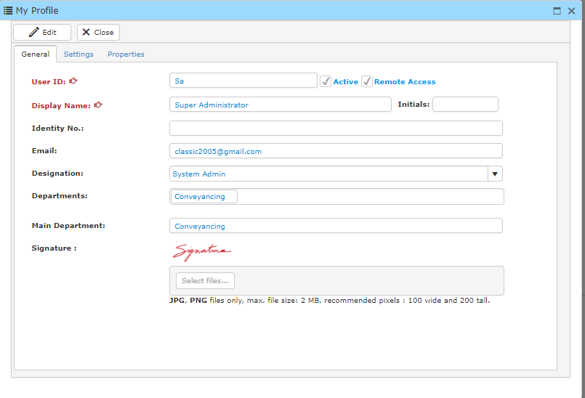

* Click **Edit** and edit any information you wish to change.
* Click **Save** once you have finished.

**13.3.3 Theme Color**

This option enables you to edit your system theme color.

* To change the **Theme Color**,go to maintenance Menu and choose the color you prefer.

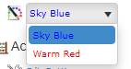

**Sky Blue**



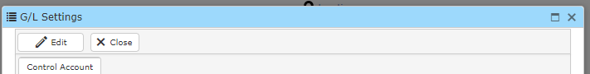

**Warm Red**



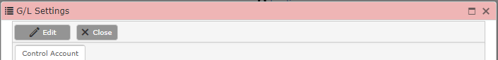

**13.4 Accounting**

**13.4.1 G/L Settings**

This option enables you to edit the G/L settings in system.

* To open ‘**G/L Settings**’ window, go to maintenance Menu and click ‘**G/L Settings**’.
* A window will show as below.

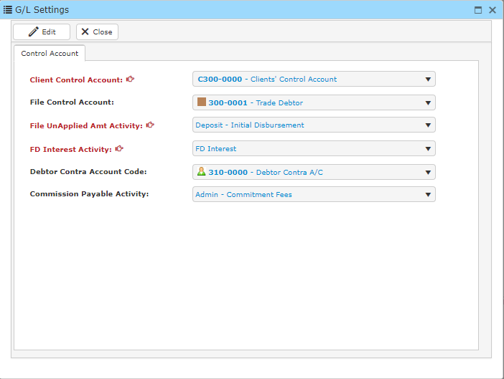

* Click **Edit** to make changes to the current settings.
* Click **Save** to proceed.

**13.4.2 Fiscal Year**

This option enables you to edit fiscal year in the system.

* To open ‘**Fiscal Year**’ window, go to maintenance Menu and click ‘**Fiscal Year**’.
* A window will show as below.

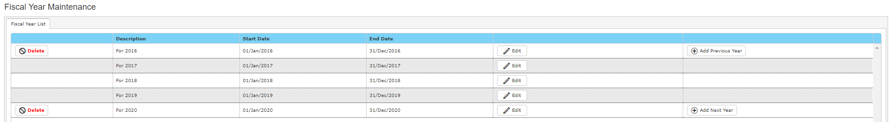

* To edit, click **Edit** and a window will be displayed as below.

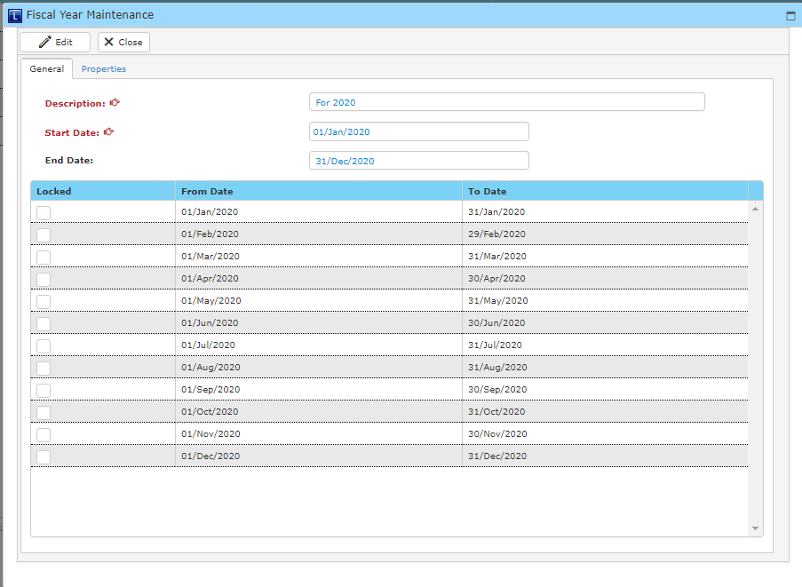

* Click **Edit**, to edit in this window.
* Tick any checkbox you want and click **Save** when you are done.

**13.4.3 GL Account Code**

This option enables you to edit or create account code in the system.

* To open ‘**GL Account Code**’ window, go to maintenance Menu and click ‘**GL Account Code**’.
* A window will show as below.

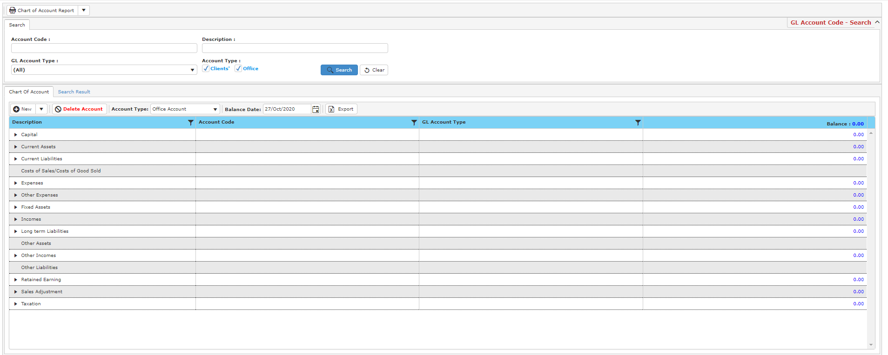

**Search Account Code**

* To find details of an account code, fill in the search criteria and click **Search** and a result list will be displayed below.

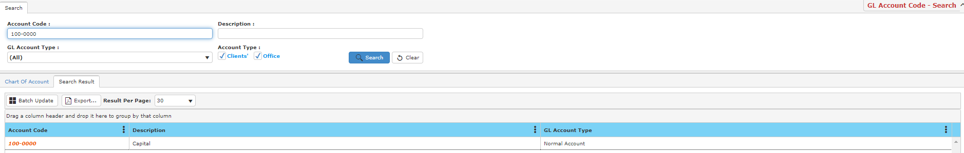

**Creating New Account Code**

* To create a new account code, click **New** in **Chart of Account** and a new window will be displayed.

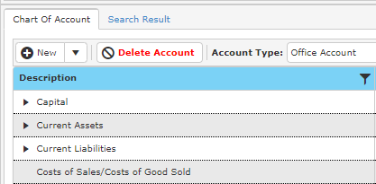

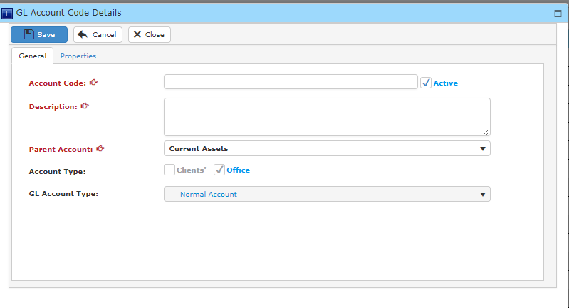

* Fill in the fields below and click **Save** once you have completed.

**13.4.4 Account Balance**

This option enables you to edit the number value of the accounts in the system.

* To open ‘**Account Balance**’ window, go to maintenance Menu and click ‘**Account Balance**’.
* A window will show as below.

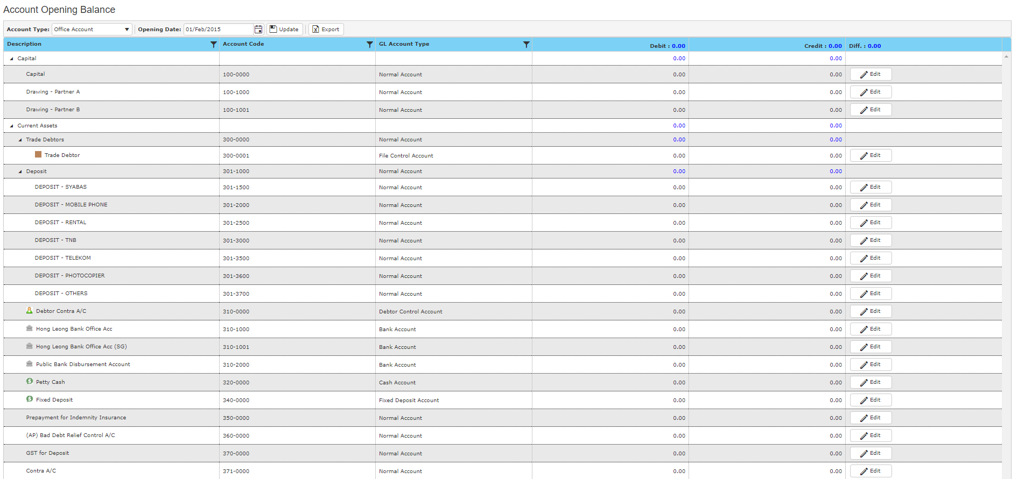

* Click **Edit** to edit the number value for the respective accounts.
* Once you have done, click **Update** to save.
* To export, click **Export** and an Excel file will be downloaded through the browser.

**13.5 Tax**

**13.5.1 Tax Settings**

This option enables you to edit the tax settings in the system.

* To open ‘**Tax Settings**’ window, go to maintenance Menu and click ‘**Tax Settings**’.
* A window will show as below.

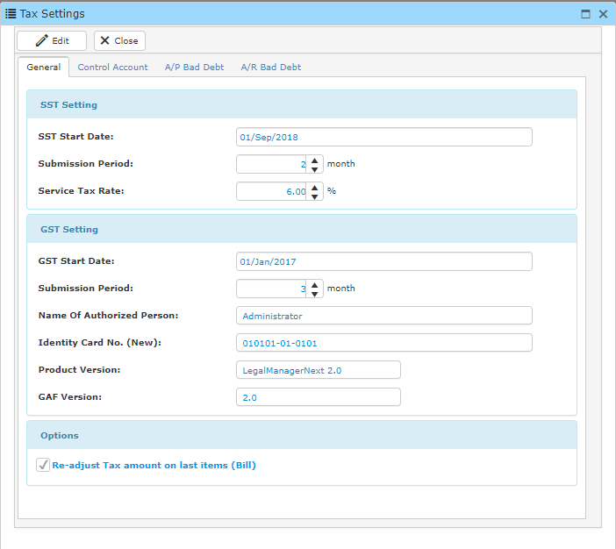

* Click **Edit** to make any changes to the current setting. You may also edit information in the following tabs:



* Click **Save** once you have done.

**13.5.2 Tax Code Maintenance**

This option enables you to edit or create tax codes in the system.

* To open ‘**Tax Code Maintenance**’ window, go to maintenance Menu and click ‘**Tax Code Maintenance**’.
* A window will show as below.



**Search Tax Code**

* To search for a tax code, fill in the search criteria and click **Search**. A result list will be displayed below.

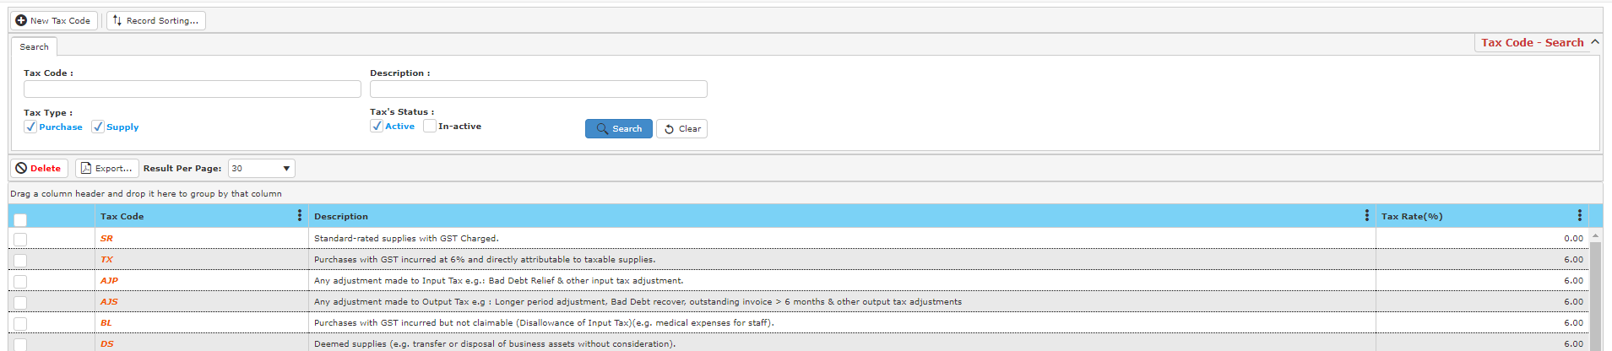

**Creating New Tax Code**

* To create a new tax code, click **New Tax Code** and a new window will be displayed as below.

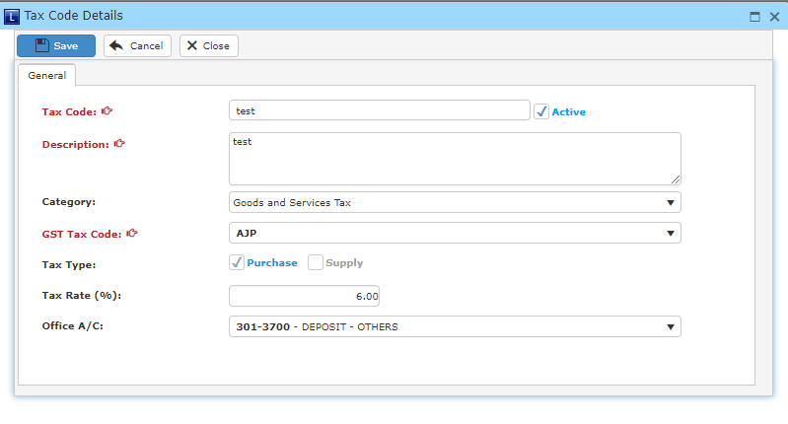

* Fill in the fields below and click **Save** once you have done.

**13.6 File Type & Templates**

**13.6.1 File Type Designer**

This option enables you to create file type in the system.

* To open ‘**File Type Designer**’ window, go to maintenance Menu and click ‘**File Type Designer**’.
* A window will show as below.



**Search File Type**

* To search for a file type, type in your search criteria and click **Search** and a result list will be displayed below.

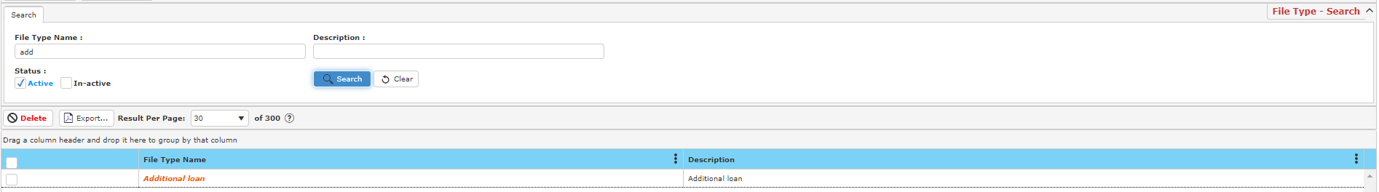

**Creating New File Type**

* To create a new file type, click **New File Type** and a new window will be displayed as below.

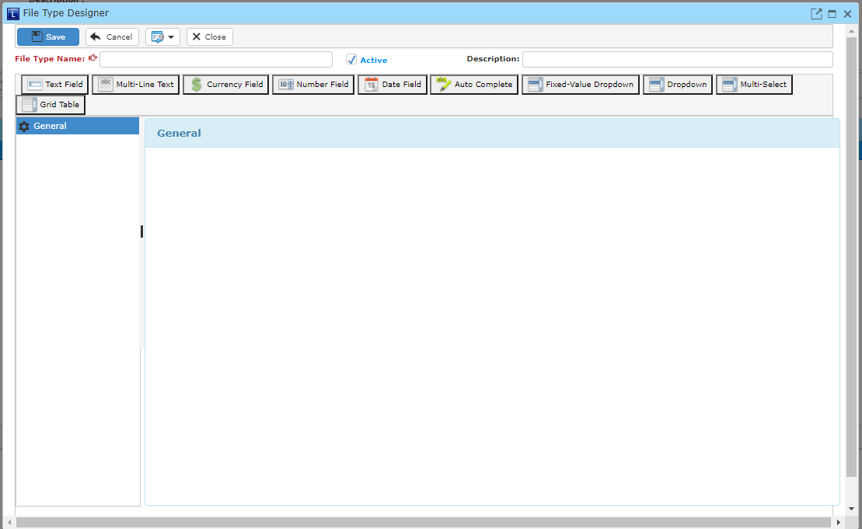

* To add in any fields into the designer, choose any of the option below and a new window will be displayed.



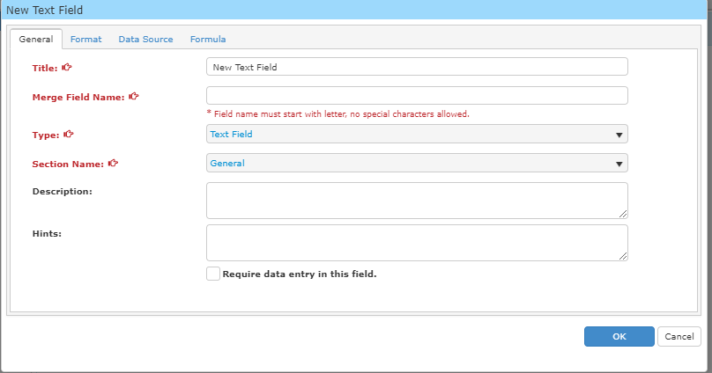

* Fill in the fields below and click **OK** to proceed.
* To add in a new field into the designer, choose and repeat the steps as above.

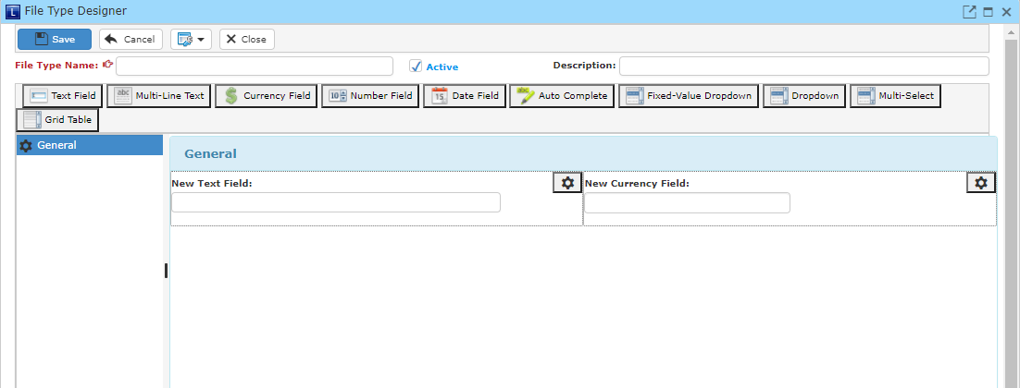

* Click **Save** once you have finished.

**13.6.2 Template Explorer**

This option enables you to edit or create templates in the system.

* To open ‘**Template Explorer**’ window, go to maintenance Menu and click ‘**Template Explorer**’.
* A window will show as below.

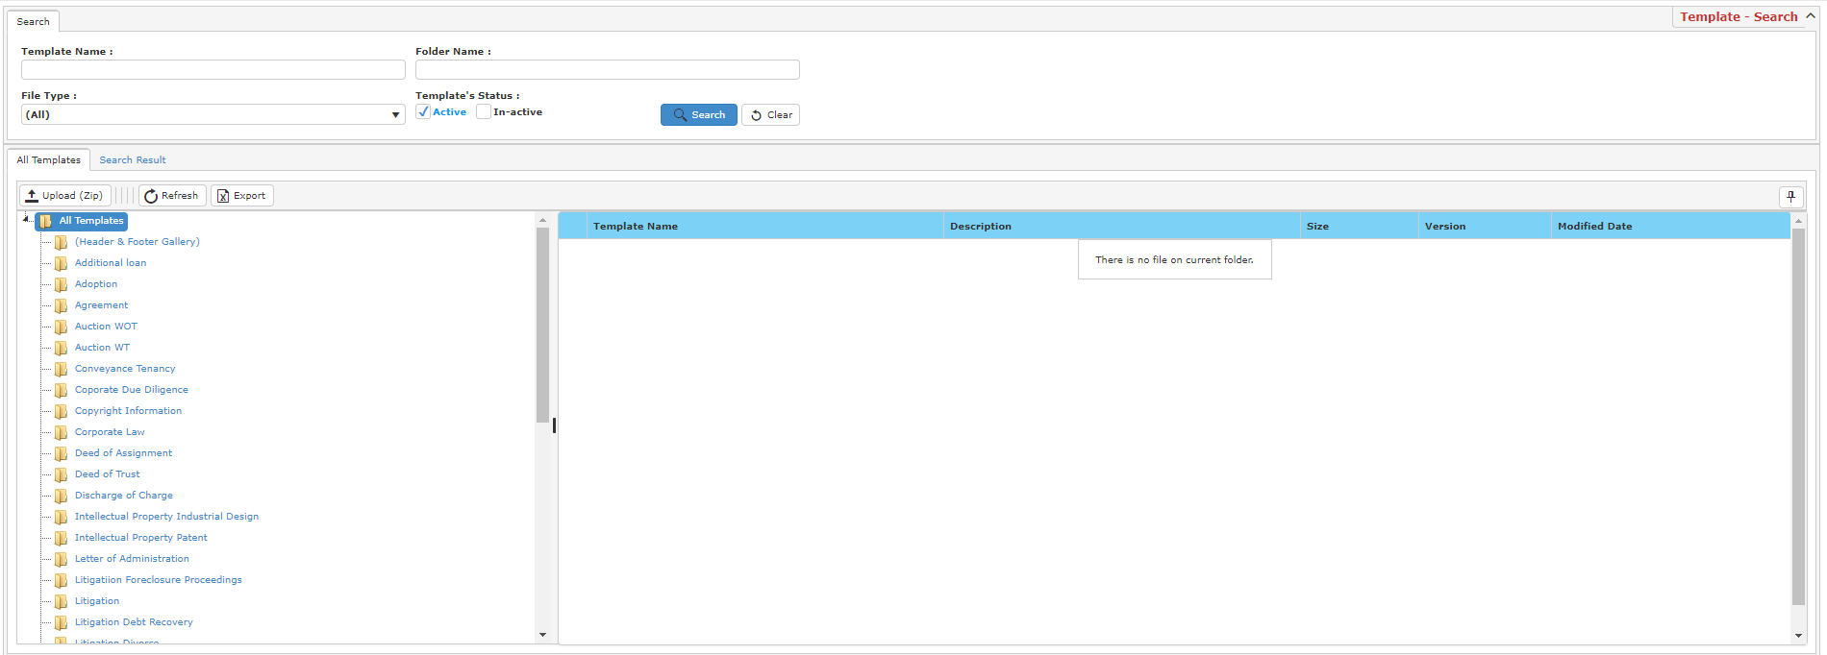

**Search Template Name**

* To search for a template, fill in your search criteria and click **Search** and a result list will be displayed below.

**Upload Template**

* To upload a template, click **Upload (ZIP)** in **All Template** and a new window will be displayed as below.

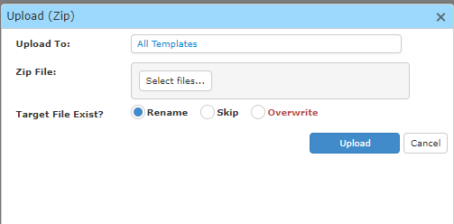

* Click **Select Files** to choose a template from your computer and click **Upload** to upload.

**Export Template**

* To export a template, select a file you wish to export and click Export and an Excel file will be downloaded through the browser.

**Creating New Template**

* To create a new template, select a folder and click **New Template** a window will be displayed as below.

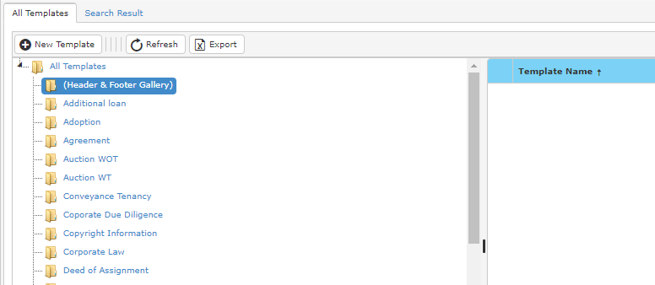

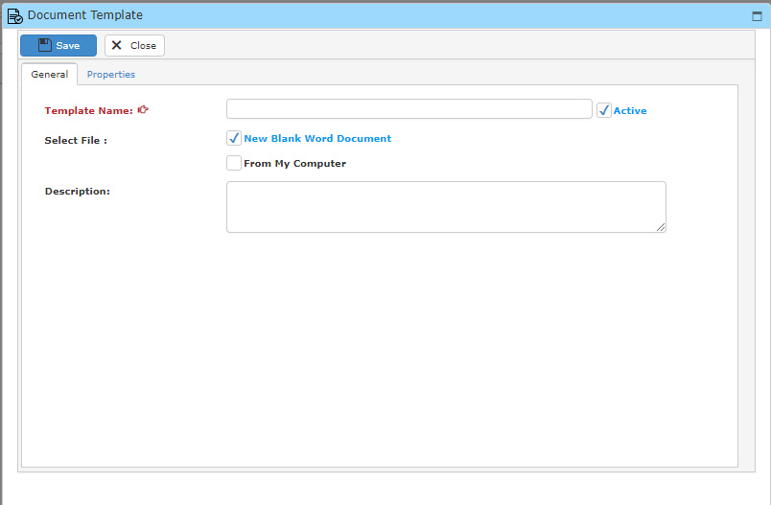

* Fill in the field below.
* If you have any template to upload from your computer. Tick “**From My Computer**” and select the file from your computer. Click **Save** once you have finished.

**13.7 Reporting**

**13.7.1 Manage Reports**

This option enables you to manage reports in the system.

* To open ‘**Manage Reports**’ window, go to maintenance Menu and click ‘**Manage Reports**’.
* A window will show as below.

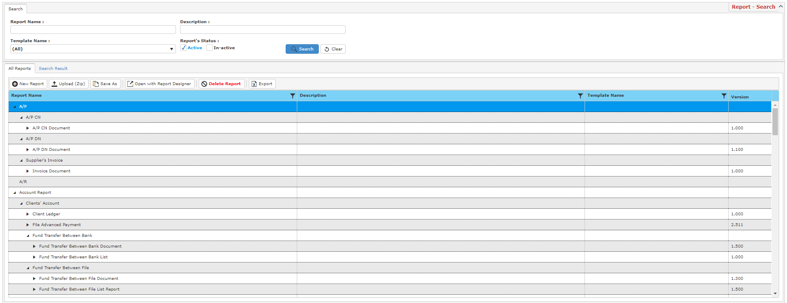

**Search Report**

* To search for a report, type in your search criteria and click **Search** and a result list will be displayed as below.

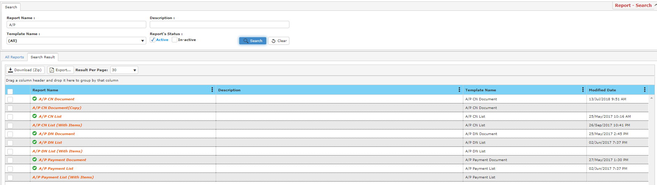

**Creating New Report**

* To create a new report, click **New Report** in **All Report** tab.

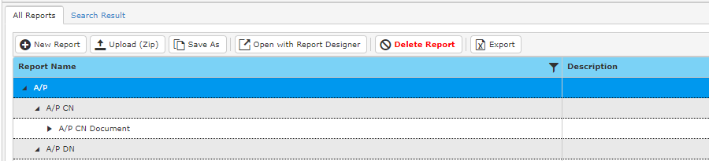

* A new window will be displayed.

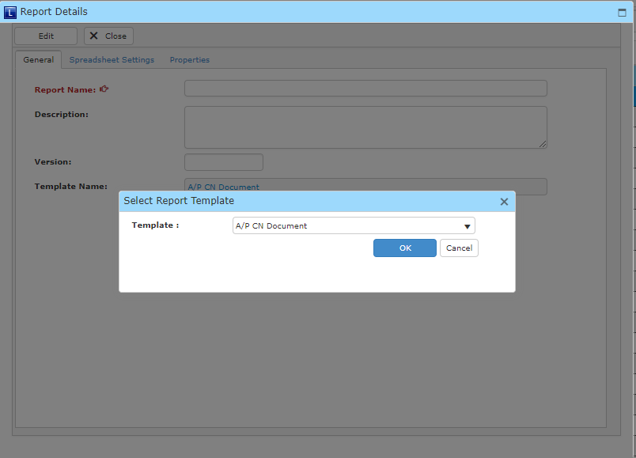

* To begin, choose a template type.

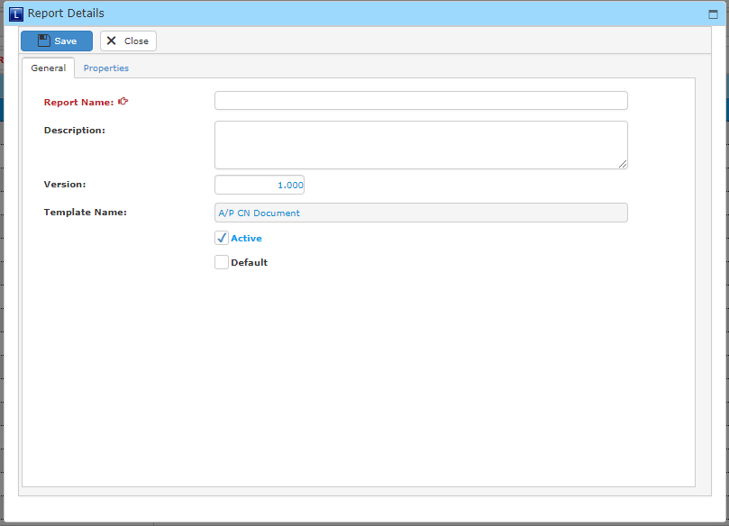

* Fill in the fields below and click **Save** once you have completed.

**Upload Report**

* To upload a report, click **Upload (ZIP)** in **All Reports** tab and a new window will be displayed as below.

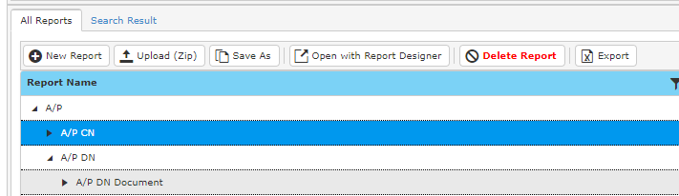

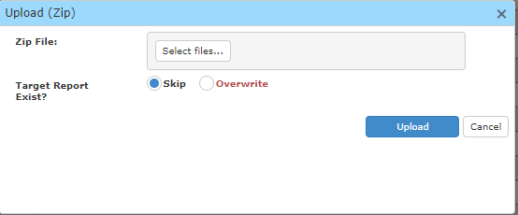

* Click **Select Files** to choose a file from your computer.
* **You** may choose skip if you wish to keep the existing report and the to-be-uploaded report.
* Click **Upload** to upload the report.

**13.7.2 Report Options**

This option enables you to edit footer and header of the reports in the system.

* To open ‘**Report Options**’ window, go to maintenance Menu and click ‘**Report Options**’.
* A window will show as below.

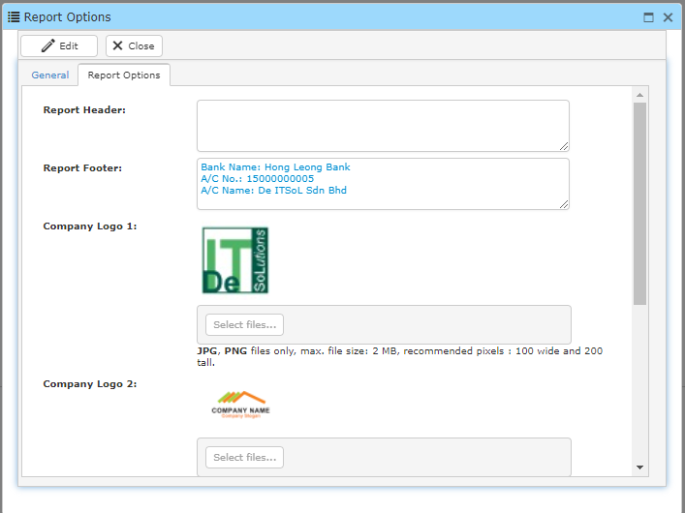

* Click **Edit** to edit any information you wish to change.
* Click **Save** once you have finished.

**13.8 System**

**13.8.1 System Event**

This option enables you to view system events.

* To open ‘**System Event**’ window, go to maintenance Menu and click ‘**System Event**’.
* A window will show as below.



* To search for an event, fill in your search criteria and click **Search** and a result list will be displayed.

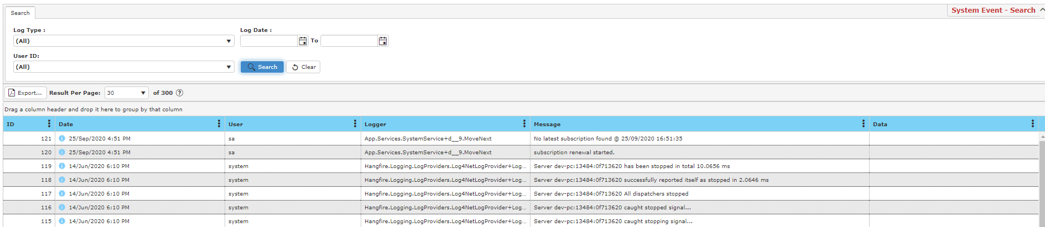

**13.8.2 Restart**

This option enables you to restart the system.

* To open ‘**Restart**’ window, go to maintenance Menu and click ‘**Restart**’.
* A window will show as below.



* Click **Confirm Restart** to restart the system.